Number
Place Value | CP2 | CP4 | CP6 | Meeting this Objective: | Working at Greater Depth:
Count in steps of 2, 3, 5 and 10 forwards and backwards | Can they count forwards in steps of 2, 5 and 10 from zero? | Can they count forwards and backwards in steps of 2, 5 and 10 from any number?  Can they count forwards in steps of 3? | Can they count forwards and backwards in steps of 2, 3, 5 and 10 from any number?  Fill in the missing numbers in a sequence counting in increments of 2,5,10 | I start with 4, and I count on in 3s, I will say 13. Yes/No  I start with 7, and I count in 5s, I will say 19. Yes/ No  I start with 9, and I count in 10s, I will say 39.  Yes/ No  I start with 8, and I count in 3s, I will say 31. Yes/ No  Moving up or down in 2s, 3s. 5s and 10s  Write the next 4 numbers in these sequences:  14, 16, 18  72, 69, 66,  17, 22,27,  33, 43, 53 | Henry thinks of a number. 5 less than his number is 16. What is his number?  Mohsin thinks of another number. 10 less than his number is 87. What is his number?  Ellie thinks of a number 3 less than her number is 34. What is her number?  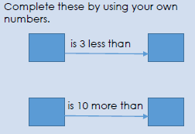
Recognise the value of each digit in a 2 digit number (tens and ones)  Identify, represent and estimate numbers using different representations, including the number line  Partition any two-digit number into different combinations of tens and ones, explaining their thinking verbally, in pictures or using apparatus | Can they show basic understanding of the value of each digit in a 2 digit number with practical resources e.g. dienes?  Can they identify numbers using different representations e.g. number line, numicon, bead string? | Can they recognise the value of each digit in a two digit number and partition numbers into different combinations of 10s and 1s?  Can they identify represent numbers using different representations e.g. number line, numicon, bead string? | Can they recognise the value of each digit in a 2 digit number and create their own numbers?  Can they estimate numbers using different representations e.g estimating where a number might be on a nearly empty number line? | Complete the following partitions, one has been done for you:  36= (30 + 6)  45 58  56 93  91 17  27 32  Create 2-digit numbers where the unit is one less than the tens.  What is the largest possible number, and what is the smallest number, you can create?  Largest Smallest | Look at the number cards below.  Using the cards make up two, 2-digit numbers that are more than 20 apart.  Now two numbers that are less than 20 apart.  Make up two numbers that are as far apart as possible.  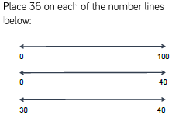
Compare and order numbers from 0 up to 100; use <, > and = signs | Can they order numbers from 0 to 100? | Can they understand and use the language of greater than, less than and equal to, to compare 2 numbers? | Can they use the <, > and = signs to compare numbers? | In a family there is mum (30), dad (32), great grandad (70), Uncle Tom (28), baby Ellen (1) and an older brother, Billy (7). On the chart below can you put them in order of age starting with the oldest? The first one is done for you.  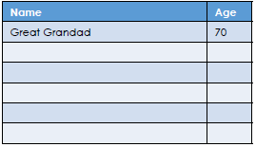  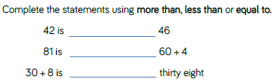 | 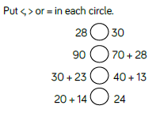  Fill in the missing numbers using 1,2,4 and 7  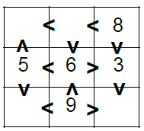
Read and write numbers to at least 100 in numerals and in words | Can they read numbers to 100? | Can they read and write numbers to 100? | Can they read and write numbers to 100 in numbers and words? | Match the numbers to the names:  16 eighteen  36 fifty-two  52 thirty-six  18 thirty  30 sixteen | 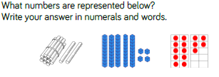
Use place value and number facts to solve problems. | Can they use their basic knowledge of place value and number facts to solve simple problems with support? | Can they use their knowledge of place value and number facts to solve simple 1 step problems? | Can they use place value and number facts to solve problems with more than one step? | 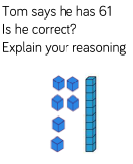 | 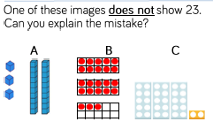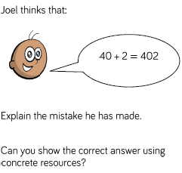
Addition & Subtraction | CP2 | CP4 | CP6 | Meeting this Objective: | Working at Greater Depth:
Recall and use addition and subtraction facts to 20 fluently and derive and use related facts up to 100 | Can they recall and use addition and subtraction facts to 10 fluently? | Can they recall and use addition facts to 20?  Can they begin to derive and use related facts up to 100? | Can they recall and use addition facts to 20 fluently?  Can they derive and use related facts to numbers to 100? | Complete as many additions and subtractions as you can to match the number in the circle.  Make up at least 10 sentences.  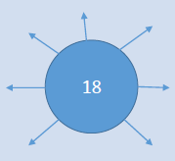  Now do the same with the following numbers in the circle:  12; 19; 15; 17; 13, 11. | 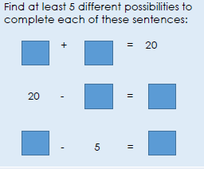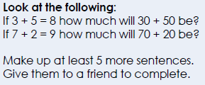
Add and subtract numbers using concrete objects, pictorial representations, and mentally, including:  . a two-digit number and ones  . a two-digit number and tens  . two two-digit numbers  . adding three one-digit numbers  Solve problems with addition and subtraction  . using concrete objects and pictorial representations, including those involving numbers, quantities and measures  . applying their increasing knowledge of mental and written methods | Can they add and subtract numbers using concrete objects (not crossing tens)?  Can they add and subtract numbers using concrete objects (crossing tens) ?  TU + U e.g. 52 + 5 =  TU – U e.g. 52- 5 =  TU + T = e.g. 45 + 20 =  TU – T = e.g. 45 – 20 =  TU + TU = e.g. 37 + 21 =  TU – TU = e.g. 37 – 21 =  U + U + U = 8 + 4 + 3 =  U – U – U = 9 – 3 – 2 =  Can they solve simple addition and subtraction problems, with some support, using concrete objects? | Can they add and subtract numbers using concrete objects and pictorial representations?  TU + U e.g. 52 + 5 =  TU – U e.g. 52- 5 =  TU + T = e.g. 45 + 20 =  TU – T = e.g. 45 – 20 =  TU + TU = e.g. 37 + 21 =  TU – TU = e.g. 37 – 21 =  U + U + U = 8 + 4 + 3 =  U – U – U = 9 – 3 – 2 =  Can they solve simple addition and subtraction problems using pictorial representations? | Can they add and subtract numbers using written method and mentally?  TU + U e.g. 52 + 5 =  TU – U e.g. 52- 5 =  TU + T = e.g. 45 + 20 =  TU – T = e.g. 45 – 20 =  TU + TU = e.g. 37 + 21 =  TU – TU = e.g. 37 – 21 =  U + U + U = 8 + 4 + 3 =  U – U – U = 9 – 3 – 2 =  Can they independently solve a range of simple addition and subtraction problems using mental and written methods? | 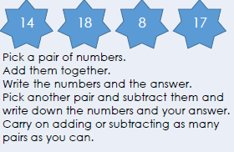  Hamza has 41 sweets.  Jemima has 55 sweets.  How many sweets do they have altogether?  Throw the three dice and add the numbers together.  Now record your results like this:  3+ 4 + 5 = 12. Do this 5 times and check your results. | There are 27 marbles in a jar.  Ahmed takes 9 and Helen takes 7.  How many marbles are left in the jar?  Record your answer.  On holiday in Greece it was 31 degrees during the day but 12 degrees cooler in the evening.  What was the temperature in the evening?  Harry has 56p.  He buys a cake for 9p and a chocolate bar for 15p. How much has he left?  Each row and column adds up to 100.  Complete the grid.  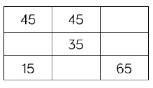  Can they solve unfamiliar word problems that involve more than one step?
Show that addition of two numbers can be done in any order (commutative) and subtraction of one number from another cannot | Can they show that if you add numbers in a different order you will reach the same total?  e.g. 9 + 3 = 12  3 + 9 = 12 | Can they show that if you add numbers in a different order you will reach the same total but if you subtract in a different order you will not?  e.g. 9 + 3 = 12 3 + 9 = 12  12 – 9 = 3 12 – 3 = 9  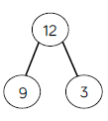 | To use their knowledge of commutivity to solve simple problems including spotting errors. | Write 4 number sentences involving + and –using the numbers 100, 67 and 33.  Now do the same with the numbers 23, 45 and 68.  Again with the numbers 17, 30 and 47.  One relationship shown by this part whole model is  15 + 5 = 20.  Can you write 4 associated facts?  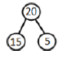 | When I take one number away from the other the answer is 36.  One of the numbers is 18.  What is the other number?  When I take one number away from the other the answer is 29.  One of the numbers is 46.  What is the other number?
Recognise and use the inverse relationship between addition and subtraction and use this to check calculations and solve missing number problems. | Can they begin to understand that addition and subtraction are inverse operations?  e.g. 7+ 3 = 10 so 10 – 7 = 3 | Can they recognise the inverse relationship between addition and subtraction and make related number statements?  e.g. 7 + 3 = 10, 3 + 7 = 10,  10 – 7 = 3, 10 – 3 = 7 | Can they recognise and use the inverse relationship between addition and subtraction and use this to check calculations and solve mission number problems? | 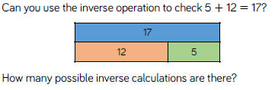  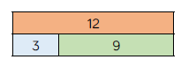  Can you write the 4 addition and 4 subtraction number sentences to match this bar model? | Emily did the following calculation:  12 − 8 = 4  She checked it by using the inverse.  She did 12 + 8 = 20 and said that her  first calculation was wrong.  What advice would you give to her?
Multiplication  & Division: | CP2 | CP4 | CP6 | Meeting this Objective: | Working at Greater Depth:
Recall and use multiplication and division facts for the 2, 5 and 10 multiplication tables, including recognising odd and even numbers | Can they recognise odd and even numbers?  Can they count in steps of 2, 5 and 10? | Can they recall multiplication facts for the 2, 5 and 10 times tables?  Can they recall division facts for the 2, 5 and 10 times tables? | Can they recall and use multiplication and division facts to solve simple problems. | 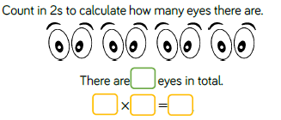 | 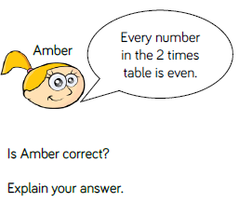
Show that multiplication of two numbers can be done in any order (commutative) and division of one number by another cannot | Can they show that multiplication of two numbers can be done in any order  e.g. 2 x 5 = 10  5 x 2 = 10 | Can they show that division of two numbers cannot be done in any order?  e.g. 12 divided by 2 = 6 but  2 divided by 12 does not equal 6 | To use their knowledge of commutivity to solve simple problems including spotting errors. | If you have 3 numbers that are related by multiplication and division, then you can create 4 number sentences, e.g. 3, 4, 12  3 x 4 = 12  4 x 3 = 12  12 ÷3 = 4  12 ÷4 = 3  Now do the same with the following sets of numbers:  15, 3 and 5 4, 5 and 20  8, 4, and 2 16, 8 and 2  24, 6 and 4 24, 8 and 3  Ali wants to treat his friends.  He wants to buy them all an orange.  At the supermarket oranges are sold in bags of 5.  Ali has 26 friends.  How many bags will he have to buy?  Explain your reasoning. | Chocolate bars cost 10p each or you could buy 3 bars for 25p  How many bars could Javed buy if he had a £1 to spend?  If Javed needed to buy 8 bars, how much will it cost him?  In the car park there is a mixture of bicycles and cars.  Altogether there were 24 wheels on the ground.  Think of the different numbers of cars and bicycles there could have been on the car park. Give at least three different alternatives.
Solve problems involving multiplication and division, using materials, arrays, repeated addition, mental methods, and multiplication and division facts, including problems in contexts.  (Within these is the objective  calculate mathematical statements for multiplication and division within the multiplication tables and write them using the multiplication (×), division (÷) and equals (=) signs | Can they solve simple problems involving multiplication and division using concrete apparatus? | Can they solve simple problems involving multiplication and division using materials, arrays, repeated addition  Record solutions using the multiplication (×), division (÷) and equals (=) signs | Can they solve simple problems involving multiplication and division using multiplication and division facts, including problems in contexts mentally? | Tubes of bubbles come in packs of 2 and 5.  Lily has 22 tubes of bubbles. How many of each pack could she have?  How many ways can you do it?  Which person has most sweets?  Tara has 5 packets of sweets with 10 in each one.  Hamid has 3 packets with 20 in each.  Lucy has 10 packets with 4 in each.  Who has the most sweets? | 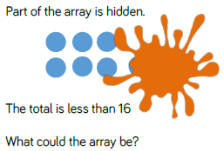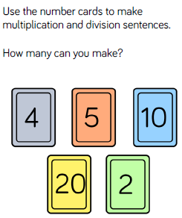  Five friends want to buy some stickers.  Each sheet of stickers has 20 stickers.  How many sheets will they need to buy if each friend has at least 10 stickers each?  How many sheets will they need to buy if each friend has at least 25 stickers each

Shape, Space and Measure
 | By the end of CP 6, can they: | Meeting this Objective: | Working at Greater Depth:
Compare and sequence intervals of time | Can they sequence events in a given day using appropriate time language i.e. morning, afternoon, evening, night, earlier and later?  Can they order a given number of time events to the given hour or half hour?  Can they work out the interval of time that has passed to the given hour? | Name 3 things that happen typically in the morning.  Name 3 things that happen typically in the afternoon.  Name 3 things that happen typically in the evening.  Name 3 things that happen typically at night.  If I arrive at school at 8 in the morning and I have lunch at 12 noon, how much time has passed between arriving and lunch?  I wake up at 7 in the morning and I go to bed at 8 at night. How much time has passed between getting up and going to bed? | True or False  It is quarter past four and it will be quarter to six in 1 and a half hours.  True or False?  It is ten past six and it was twenty to four an hour and a half ago.  True or False?  It is twenty past three and it will be ten past five in 2 hours’ time.  True or False?
Tell and write the time to the nearest 15 minutes, including quarter past/to the hour and draw the hands on a clock face to show these times | Can they read the clock to o’clock and half past?  Can they read the clock to quarter to and quarter past?  Can they draw times on the clock to o’clock, half past, quarter to and quarter past? | 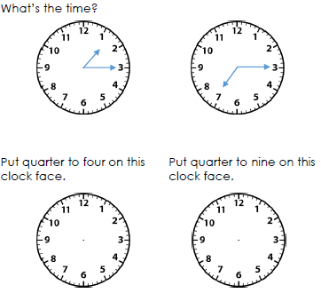 | 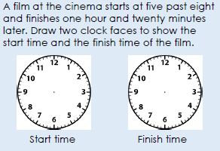
Combine amounts to make a particular value. Find different combinations of coins that equal the same amounts of money. Solve simple problems in a practical context including giving change | Can they recognise all coins between 1p and £2?  Can they add any two amounts of money up to the value of £2?  Do they know how many 50p; 20p; 10p; 5p; 2p and 1p coins you need to make up to £1?  Can they recognise the symbols for pounds (£) and pence (p) and use these correctly?  Can they find the difference between two amounts including giving change from any amount up to £1? | Show 2 ways in which you can make 68p using only 20p, 10p and 2p coins.  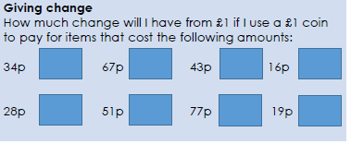 | 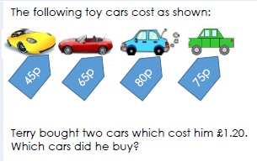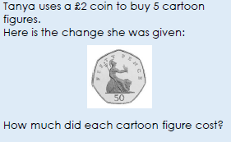
Choose and use appropriate standard units to estimate and measure length/height, mass temp., capacity to the nearest appropriate unit, using rulers, scales, thermometers and measuring vessels Compare and order lengths, mass, volume/capacity and record the results using >, < and = | Do they know that capacity is measured in l/ml, length and height in m/cm, mass in kg/g and temperature in degrees Celsius?  Can they fill a measuring jug to a given amount in litres or ml (and other measures), reading the scale?  Read scales in divisions of ones, twos, fives and tens to determine the length, height, mass or volume.  Can they measure and draw lines to the nearest cm using rulers?  Do they know that 1000ml is the same as 1 litre and 100cm is a metre.  Can they choose the appropriate standard units  Can they use the >, < and =symbols to compare and order amounts of liquids? | 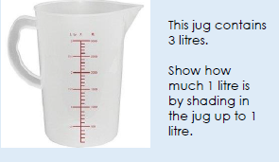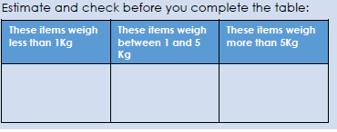  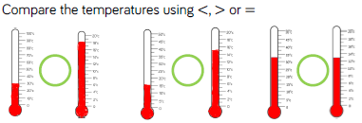 | 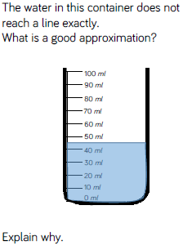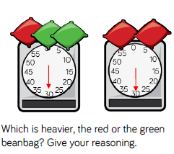
Name and describe properties of 2-D and 3-D shapes, including number of sides, vertices, edges, faces and lines of symmetry. | Compare and sort common 2d and 3d shapes  Identify and describe the sides and vertices on 2d shapes  Identify the lines of symmetry on a 2d shape  Identify and describe the faces, edges, vertices on 3d shapes  Identify the 2d shapes on the faces of 3d shapes  Name common 2d shapes  Name common 3d shapes | 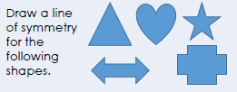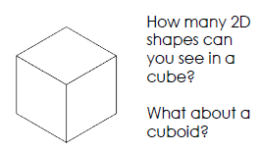 | 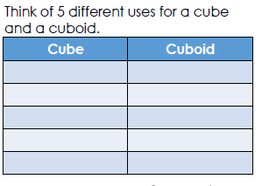
Fractions
 | By the end of CP 6, can they: | Meeting this Objective: | Working at Greater Depth:
Recognise, find, name and write fractions ½, 1/3, 1/4, 2/4 and ¾ of  a length, shape, set of objects or quantity | Can they recognise that ½ stands for half and can they find half of a length, shape or set of objects or quantity?  Can they recognise that 1/3 stands for third and can they find a third of a length, shape, set of objects or quantity?  Can they recognise that ¼ stands for quarter and can they find a quarter of a length, shape, set of objects or quantity?  Can they recognise that ¾ stands for three quarters and can they find ¾ of a length, shape, set of objects or quantity? | 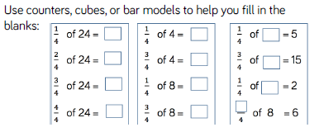  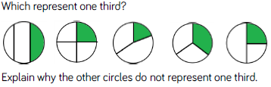 | 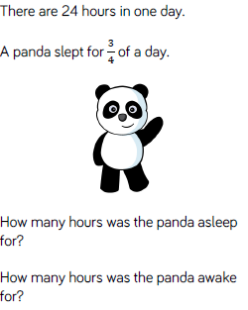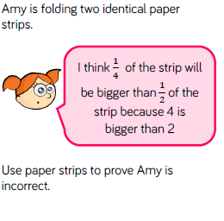
Write simple fractions, for example ½ of 6 is 3 and recognise the equivalence of 2/4 and 1/2. | Can they recognise the written fractions e.g. ½, ¼, ¾?  Can they calculate simple fractions e.g. ½ of 6 is 3?  Can they recognise that ½ is the same as 2/4? | 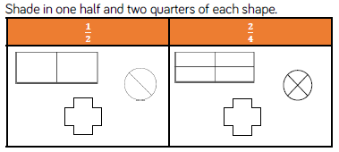 | 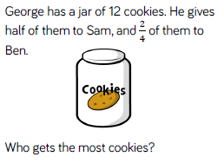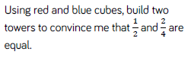
Key Performance Indicators (KPIs) must be achieved to be awarded the expected standard or greater depth

Key for Shape, Space, Measure and Fractions
Red- Working towards Objective
Yellow- Working towards Expected Target
Green- Expected target met on Objective

