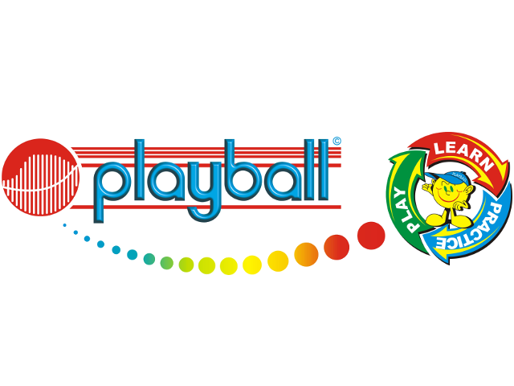
Dear Parents,
I am delighted to announce that after the summer holidays we will be back offering early drop off sessions for the Nursery children at Crawley Ridge on Tuesday and Thursday mornings 8:30 – 9am. Spaces are given on a first come first serve basis, so email playball.harry@gmail.com your child’s name, date of birth, relevant medical notes and a contact number. There are multi-day discounts for those who book into both sessions. Session will only run if there are enough children booked in to cover our costs.
Kind Regards,
Harry Simmonds
07588681052
What is Playball?
Playball is a is a multi-sports programme that teaches life skills to children through sport and movement. Our progressive curriculum is designed and researched by Occupational Therapists and Sports Scientists, and is constantly being updated inline with the latest trends and findings. At Playball the children participate in games and skills that cover 8 sports; Football, Tennis, Rugby, Hockey, Baseball, Volleyball, Cricket and Basketball.
Playball at Crawley Ridge – Auutmn Term
Tuesdays / Thursdays 11-week term
1 day - £71.50 (£6.50 per session)
Both days - £130
Start: 15th / 17th September
End: 8th / 10th December
Payment should be made by the start of term and details will be sent out at the time of booking. Payment can be made in instalments if easier for parents.



