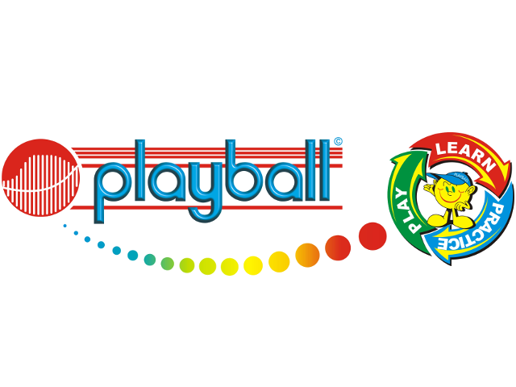
Dear Parents,
PLAYBALL HOLIDAY CAMPS AND DROP IN SESSIONS ARE BACK!! This summer we will be offering more camps and drop in sessions than ever before, however spaces at each will be limited so you will need to book early to secure a spot on your preferred dates. As always, the holiday activities are open to everyone, so feel free to get siblings involved and spread the Playball word to all your friends.
Over the course of the summer Playball will be running 16 holiday camps for children aged 3 - 12. You can book into as many or as few camps as you wish, and discounts will be on offer to those attending multiple days. Our camps will be running at Frogmore Infant School, Lightwater Village School, Bagshot Infant School and London Road. We will also be running shorter 45-minute drop-in sessions for 2 – 11 year old children to attend.
What do the camps entail?
The camps are a 3 hour drop off service for children aged 3 - 12 years. Parents get to take the morning off and rest assured that your kids will be happily entertained, well looked after, and when we hand them back to you, will be thoroughly exhausted from all the fun and games! The children are split into age-appropriate groups, where we maintain our Playball ratio of coaches to children, and we guarantee a high quality and fun filled day of sports activities and games, followed by the ever-popular treasure hunt- to ensure that the kids are sent home happy. Weather permitting, we will also make use of the water bombs and water gun games to cool off the kids.
Date / Time (For drop ins please look on our website)
All camps run 10am – 1pm
Frogmore Infant School – 28th July, 29th July, 7th Aug.
Lightwater Leisure Centre – 23rd July, 3rd Aug, 4th Aug.
Bagshot Infant School – 13th Aug, 14th Aug, 24th Aug, 25th Aug.
Crawley Ridge Infant School – 17th Aug, 19th Aug, 20th Aug, 1st Sept.
Great Hollands Recreation Ground – 12th Aug, 28th Aug.
Cost, payment and DISCOUNTS
1st day of camp: £27.50
Every additional camp after your 1st camp: £20 per day
Sibling Discount 1st day: £27.50 for the first child, £20 for every child after.
BOOK 5 CAMPS PAY FOR 4
Payment needs to be made the week before your first session.
Drop In Sessions
Drop In Sessions AM and PM throughout the summer. 45 minute sessions at a variety of locations including, Sandhurst Memorial Park, Lightwater Leisure Centre, London Road Rec and Great Hollands Rec. £10 per session. BOOK 5 CAMPS PAY FOR 4
Any questions regarding discounts for siblings / multiple days, please get in touch.

How to Book…
For safeguarding and insurance purposes all bookings will need to be made through our website www.playballkids.com/f/586. Please note, the website doesn’t take into account any multi-day / sibling discounts, if you are unsure of the cost please get in touch.
For more information or assistance with the booking process please do not hesitate to contact us. We look forward to seeing you all at our holiday camps.
Kind Regards,
Harry Simmonds
07588681052
Playball.harry@gmail.com


