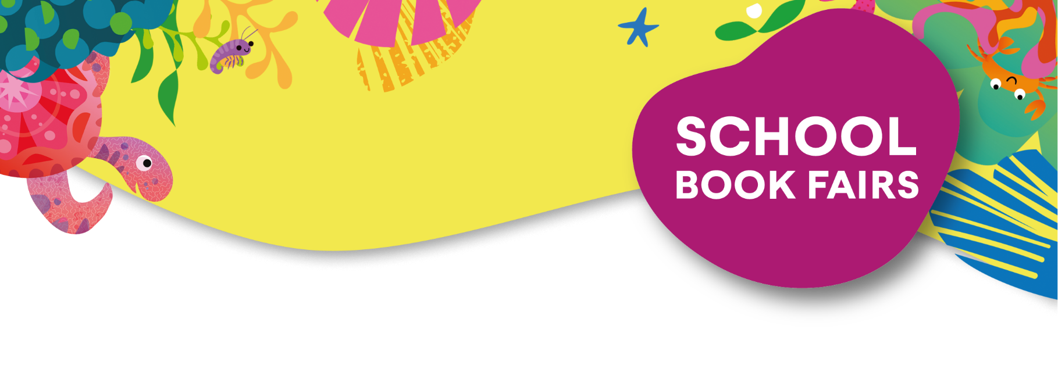

Dear Parent/Guardian,

To promote reading for pleasure and to encourage our pupils to read more broadly, we are having a School Book Fair on Friday 19th June 2026. Your children will have the opportunity to visit the fair and complete a wish list during the school day, the fair will then be open to pupils and parents after school.

Books can be purchased on the day of the book fair and paid for by cash or debit/credit card. Alternatively, you can browse the full range and order online via this exclusive link:

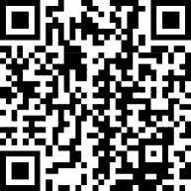

The Book Fair is being organised in conjunction with our local Usborne Schools Partner, Katie Slingerland, and every book purchased will go towards brand new FREE books for our school.

Usborne will donate 60% of the total book fair sales value raised in FREE BOOKS to the school. So, for every £1,000 of books purchased, we will earn £600 in FREE Usborne books for our school!

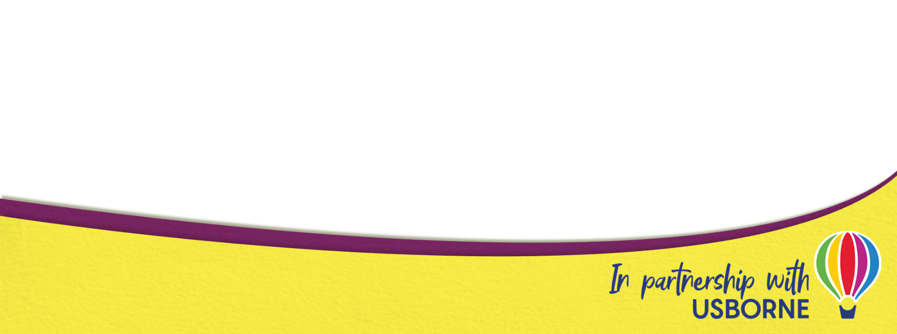
For more information and for tailored book recommendations for your child, please contact: Katie Slingerland – katiebooklady@gmail.com or 07933 728936.


