Dear Parents/Carers,
Today author Sean Perkins visited our school and read his latest release, Oscar and Ben – The Sleepover. This is the third book in the popular Oscar and Ben series.
Many of you ordered signed copies of his books in advance and your child will bring that home with them today.
Sean is in the area for the next few days, so if you would still like to place an order, please complete and return the slip below by Friday 13th March and Sean will then drop in more signed copies for your child to bring home next week. Tick the title(s) you wish to purchase and enclose payment in a sealed envelope clearly marked with your child’s name and class or teacher’s name.

In addition to Oscar and Ben – The Sleepover, Sean also has copies of the first two books in the series available. A special discounted price is available for multiple purchases:
- £22.00 for all three books
- £15.00 for any two books
- £8.00 for a single book
Yours sincerely,
Mrs Clare Roberts
Assistant Headteacher
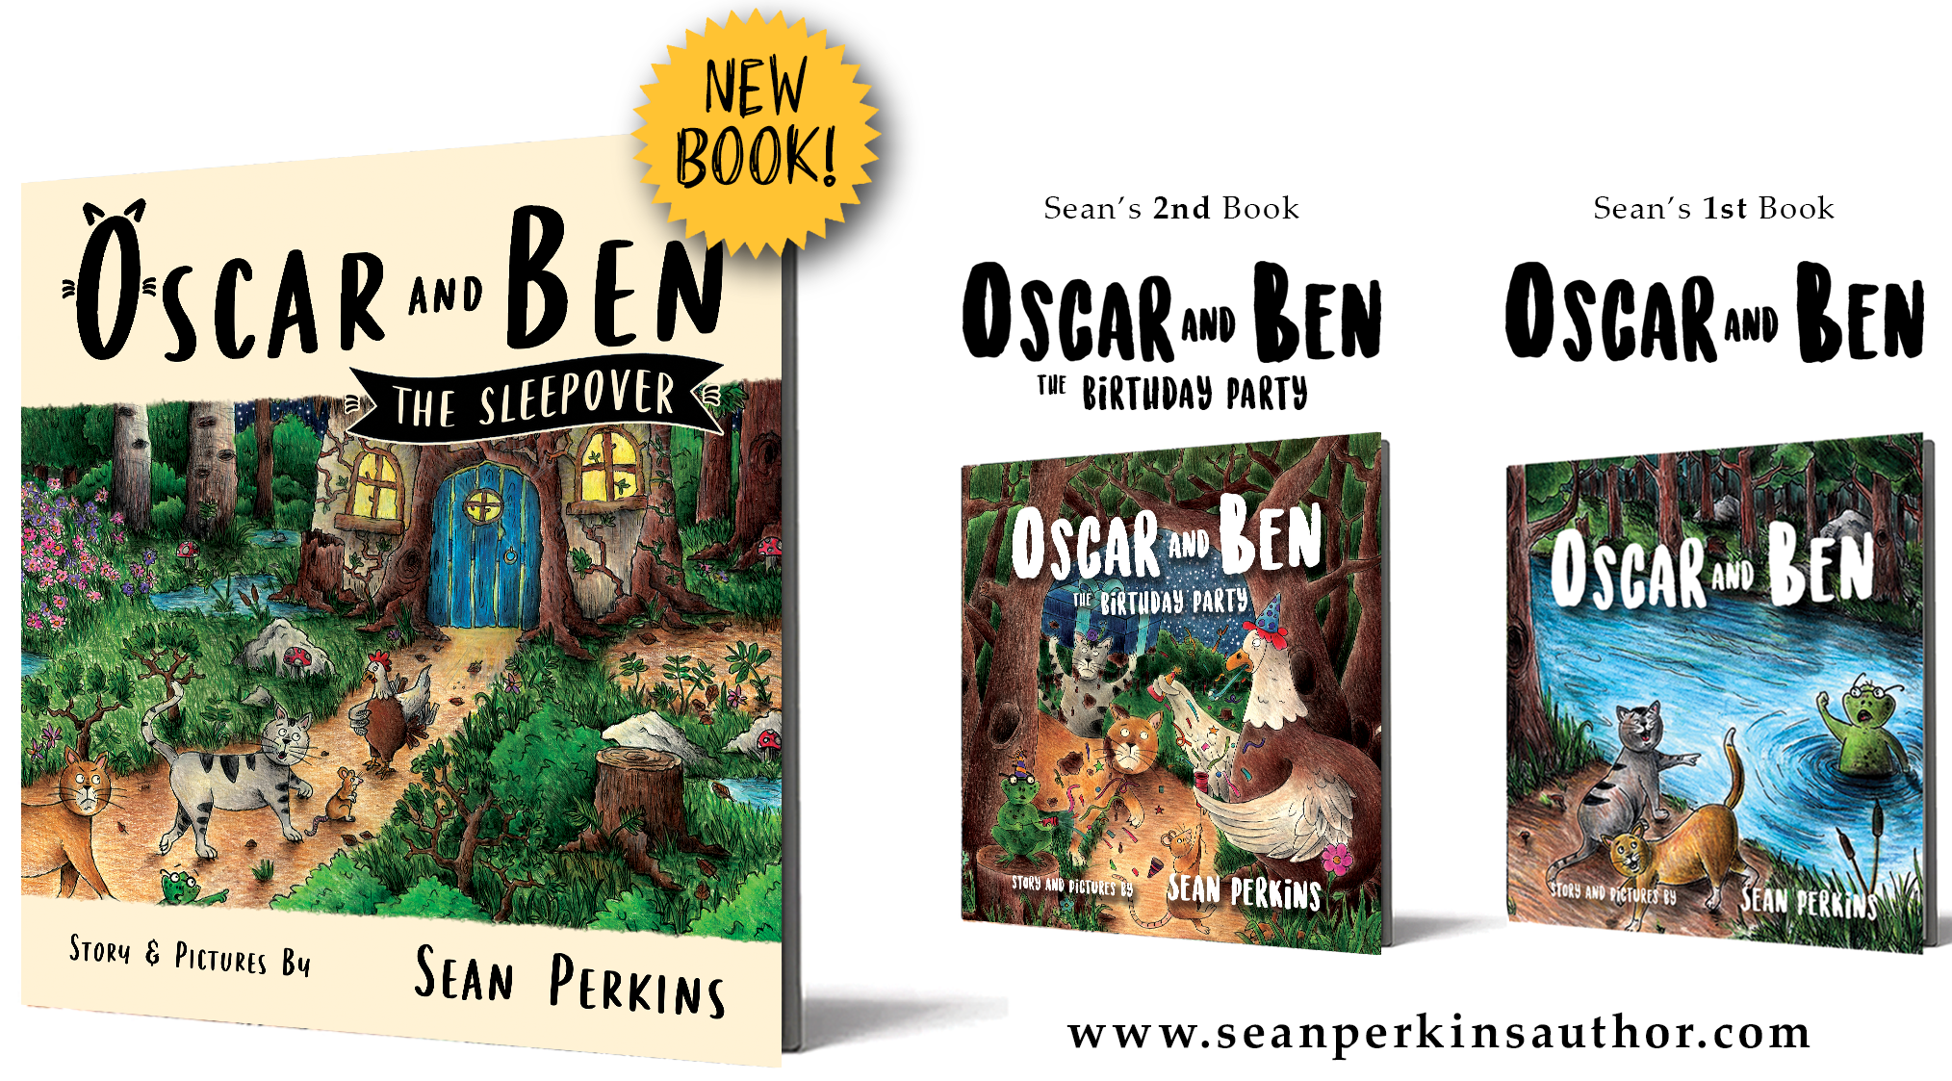

Book Order Slip
Child's Name (please print) ___________________________________________
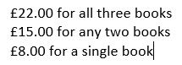
Child's Teacher/Class (please print) _________________________________________
I enclose £__________ cash for the following title/s:
Sean’s latest book ‘Oscar and Ben – The Sleepover’

Sean’s second book ‘Oscar and Ben - The Birthday Party’

Sean’s first book ‘Oscar and Ben’

