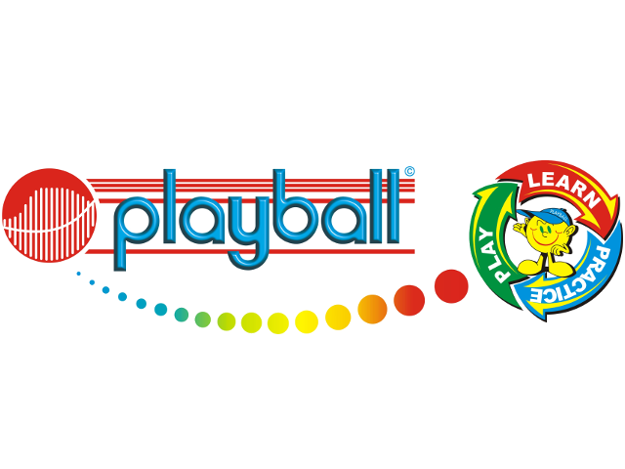
Dear Parents,
I am delighted to announce that after the Easter holidays we will be back offering afterschool sessions for Reception, Year 1 and 2 every Monday, Tuesday and Wednesday. Spaces are given on a first come first serve basis, so please head over to www.playballkids.com to book or email playball.harry@gmail.com for more information. You can book into 1, 2 or 3 weekly sessions.
Kind Regards,
Harry Simmonds
07588681052
What is Playball?
Playball is a is a multi-sports programme that teaches life skills to children through sport and movement. Our progressive curriculum is designed and researched by Occupational Therapists and Sports Scientists, and is constantly being updated inline with the latest trends and findings. At Playball the children participate in games and skills that cover 8 sports; Football, Tennis, Rugby, Hockey, Baseball, Volleyball, Cricket and Basketball.
Playball at Crawley Ridge – Summer Term
Monday’s 11 week term - £96.80 (start a week later and no classes on 4th May)
Tuesday’s 13 week term - £114.40
Wednesday 13 week term - £114.40
Start: 14th April
End: 15th March
Payment should be made by the start of term and details will be sent out at the time of booking. Payment can be made in instalments if easier for parents.
Trial Class
If you’re unsure then you are welcome to come along for a free trial class before committing for the remainder of the term. When emailing please make it clear that you wish to have a trial.
Kind Regards,
Harry Simmonds
playball.harry@gmail.com / 07588681052


