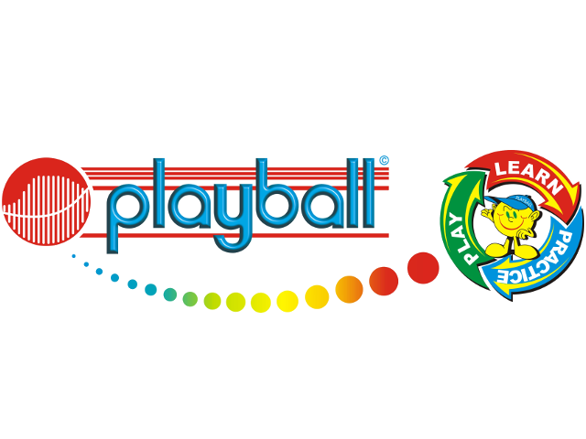
Dear Parents,
Over the last few weeks your child has attended some free Playball sessions at nursery. I am delighted to announce that after half term we will be back offering early drop off sessions for the Nursery children at Crawley Ridge. We will be running the sessions 8:30 – 9am every Tuesday and Thursday. To book all your need to do is email me your child’s name, date of birth, any relevant medical notes, days at the nursery, days you wish them to attend Playball and a contact number. Spaces are given on a first come first serve basis, so please email playball.harry@gmail.com for more information. Please note, the session will only go ahead if enough children book in to each day.
Kind Regards,
Harry Simmonds
07588681052
What is Playball?
Playball is a is a multi-sports programme that teaches life skills to children through sport and movement. Our progressive curriculum is designed and researched by Occupational Therapists and Sports Scientists, and is constantly being updated inline with the latest trends and findings. At Playball the children participate in games and skills that cover 8 sports; Football, Tennis, Rugby, Hockey, Baseball, Volleyball, Cricket and Basketball.
Playball at Crawley Ridge – Autumn Term
Tuesdays / Thursdays 6 week term
1 day - £39 (£6.50 per session)
Both days - £71.50
Start: 4th / 6th November
End: 9th / 11th December
Payment should be made by the start of term and details will be sent out at the time of booking. Payment can be made in instalments if easier for parents.



