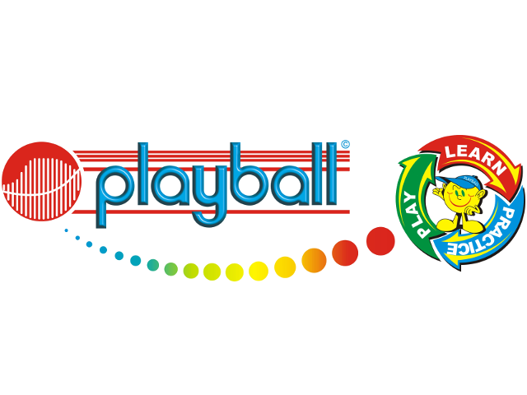
Dear Parents,
During the Autumn term your child attended some free Playball classes at Crawley Ridge Nursery, and I am delighted to announce that we will now be running weekly classes for children that attend the Nursery. Many of the children have older siblings that attend the school so we will be offering 8:30 – 9am sessions every Tuesday and Thursday which will allow you to drop your little one off with us at the same time as your school drop off. Please drop your children off to the MUGA (cage) on the Key Stage 1 playground. If you don’t have an older child at the school then you are still welcome to take advantage of the early session. At the end of the session we will drop the children off at the nursery. Children must be able to use the toilet independently to join these sessions.
Key Information – Spring Term
Dates: 11 week term w/c 13th January – w/c 31st March (no session during half term)
Time: 8:30am - 9am
Cost: £71.50 (£6.50 per session) 1 session a week
£132.00 (£6 per session) 2 sessions a week
Payment can be made in 2 instalments if needed
If you would like to register your child, please email Harry Simmonds at playball.harry@gmail.com. Spaces are given on a first come first serve basis and the session will only run if enough children sign up. If you have any queries or would like to know more about our curriculum, please feel free to get in touch.
Kind Regards,
Harry Simmonds
Playball Camberley and Bagshot
Owner
07588681052
www.playballkids.com/f/586

Age 2-3
- Developing confidence and learning to participate independently
- Using sports skills to enhance gross motor development
- Listening to instructions and audio processing tasks
- Turn-taking, sharing and social skills
Age 3-4
- Motor planning and co-ordination
- Introduction to fine motor and manipulation skills (using tennis rackets and hockey sticks)
- Increasing concentration span.


